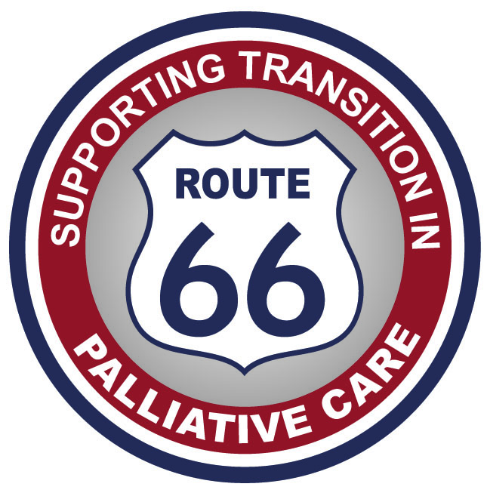

Route 66 Appeal
The Route 66 Appeal is raising money to improve the lives of 16 – 30 year olds with life limiting conditions in Wales.
Created by Dr Lidstone (Consultant in Palliative Care) and Sarah Clements (Physio in Palliative Care) who work with young people across Wales with incurable and life limiting conditions, Route 66 is a group of projects all of which are designed to improve the lives of their patients.
These young people are a ‘new’ population in healthcare- advances in medicine mean that children with life-limiting conditions who may previously not have survived past the early years are now living into early adulthood. This is great news but it comes at a cost- These young adults are often reliant on very high levels of medical and practical support from day to day; for example, many of them will require 24/7 care and will use ventilators and other medical devices.
This group of young people have a wide variety of medical conditions, such as neuromuscular, metabolic, respiratory and cardiac illnesses: but they all face many difficulties day to day, and an uncertain future.
Living with a life limiting condition presents many challenges and these young peoples’ lives are hugely limited by their medical problems but their attitude is generally get up and get on with life regardless. Route 66 will support them to do this, by providing equipment they need, by raising awareness and supporting training amongst adult service providers and by supporting them to get out and about for leisure pleasure and work, just as their healthy peers do.
Why is it important? Funding for sick children is a given- but when you reach 18yrs and still have the same issues, where do you go? There is currently no funding available to buy things like the adapted chair one of patients needs, no funding to get training done, no funding to get these people out of the house.
We need your help to raise funds to improve the lives of life limited young adults in Wales-What can you do?

What could you do?
- Follow us on twitter @route66appeal & Raise our profile now!
- Enjoy a coffee morning with friends or have a wine tasting
- Organise a band for an evening or a have a talent contest
- Have a book swop or a clothes swop or a toy swop
- Run a marathon, or go for a sponsored walk
- Do a swimathon or a welly throwing contest
- Donate your pocket money once a month
- Get your school involved
- Wash some cars for fun
- Have a water fight and charge for the water, guns and raincoats
- Hold a Raffle
- Have a clear out and donate your e bay profits
- For more ideas and help with your event visit Justgiving.com

Donate today!
You can help Route 66 raise money for this great cause by donating directly to their fundraising page http://www.justgiving.com/victoria-lidstone.
JustGiving sends your donation straight to Cardiff and Vale ULHB, where Route 66 is a subsidiary appeal and automatically reclaims Gift Aid if you are a UK taxpayer, so your donation is worth even more.
Your money will help these young people, who live every day with huge challenges, and who would just like to do the things other young people their age do every day. Please help us make their lives, however short they will be, just a little bit better.

- Thank you for your support!

